**GeoAid Business Case**

Group 18 Howest Brugge

Senne Vandecasteele, Luca Boel, Jarne Losschaert, Lucas Guillemyn, Rembrandt Verbrugghe

# Table of contents

**Table of contents** **2**

**1. Our concept** **4**

General concept 4

Reason 4

Premium 5

Our vision 5

Support 5

External companies 6

**2. Organisational structure** **7**

Flow 7

**3. Risk management** **8**

**4. Risk Profiles** **9**

Risk consequences 9

Server overload & connection problems 9

Ddos attack 9

Gps location error 9

Threat of hacking 9

Displaying the wrong information 9

Sensors stopped working 9

Risk likeliness 9

Server overload 9

Ddos attack 10

Displaying the wrong information 10

Threat of hacking 10

Connection Lost 10

Sensor errors 10

Gps location errors 10

**5. Inventaris of risks** **11**

Steps 11

What if there is a security breach? 11

What if there is a system failure? 11

**6. Strategic partnerships** **13**

Partner group 13

Who 13

Company ethics 13

**7. Marketing and sales** **13**

Objectives 13

Objective 13

Time Management 14

Realisation 14

Ideal buyer 14

Sale strategy 14

Normal User 14

Businesses 14

**8. Marketing Strategy** **15**

Customer 15

Core 15

Actual product 15

Augmented product 15

USP (unique selling proposition) 15

Cost 15

Free user 15

Premium user 16

Communication: extra means 16

Convenience 16

**9. Financials** **17**

Costs 17

Fixed costs 17

1. Staff costs 17

2. Software Licences 17

3. Office instalment 18

4. External data 18

5. Monthly deprecation 18

6. Advertisement 18

Variable costs 18

1. Server 18

2. Hardware 18

Revenue 19

Premium Users 19

Premium businesses 19

Profit 19

Break even 19

Graph & table 20

Financial mix 20

**10. Business Model Canvas** **21**

**Appendices** **22**

# Our concept

## General concept



GeoAid is an application that enables people to look at maps of the area in domes and to see which areas have been claimed by who and what sector. It also shows other data in a heatmap such as crime rates, commerce and other interesting data.

Within the mining settlements the application may be most useful to decide where to put certain refinery factories in order to reduce transportation. However criminality is also rampant in the closed in and dark mining towns, and thus having the ability to evade these areas is most useful. However, the app could prove useful to find out what equipment to take into the mines, as the temperatures often fluctuate between different shafts and earthquakes are more common in certain areas. Using the monthly and mostly yearly data, miners could easily analyse how to go about their mining operations.

In the space station the application would be heavily promoted to people arriving from Earth, as this is an absolute must have. However, besides that the application doesn’t have much use inside of the space station. Assuming there’s no rampant crime gangs up there.

Inside of the surface colonies the application truly shows all of its uses, as every single feature can be actively used almost every single day.

## Reason

In a new and unknown world we wanted to provide people with the comfort of safety. A comfort we all deserve, that is why we have come up with an application such as this one. We keep people from starting business areas where commerce doesn’t work well, avoiding bankruptcy. But we also help people find the right area to put their houses and live with their families, preferably in peace. By showing crime rates, data of car accidents, important builds such as schools, recreational facilities and the like, we provide the new world with a chance of normality.

But this goes much further than just where to put your house or business. It also aids you in knowing which areas to avoid, we want to lower the amount of people that get killed on the streets of Mars. Mars was supposed to be a place of life and not of death. Thus we will show people when they are entering or close to a dangerous zone, be it for traffic, crime, broken temperature control units or other devices that stand in for life support.

## Premium



Like any and all businesses we need to make a living, thus we have come up with the idea to implement a premium user feature. This feature is more of a service we provide than a classic app feature. Namely one of our employees will personally aid you in finding the best possible place for your business, house, factory, farm or anything you could possibly want. We hold count with every possible factor, the population type, amount, interest. Premium users get the opportunity to contact a GeoAid employee to have a chat about a new business location.

## Our vision

“Keeping you and your business safe”, this is truly our vision that we follow and believe in. Thus we achieve this with impeccable strictness on having truly correct data in our archives to help our customers with.

## Support

Like every decent business, we provide proper user support. We give the option of making tickets which are looked after by our employees. Any and all problems are always taken care of as quickly as possible. For Premium users we obviously offer the extra support in the way of consultancy for marketing and localisation of business, houses, factories and such.

## External companies

GeoAid cannot handle all of the work on its own, therefore we work together with other companies. These companies provide us extra data which saves us the money and time of gathering them ourselves.

# Organisational structure

## **Flow**

This company is one with a very modern approach and work ethic. Every department handles its own matter, but they also work together to achieve a proper end result. To prevent fights between the departments, the CEO acts as a sort of coach and middle person between the different heads of departments. Information is the bread and butter of our company, and we try very hard to communicate all that information to our employees and make sure everyone is always on the same page. We believe in the concept that our company is one big family. Therefore we prefer to hire people and give them a specialised education. We don’t take freelancers at all, because they don’t fit into our company ideal of one big family. In the future we plan expansions in the sense of hiring more cyber security engineers and software engineers.

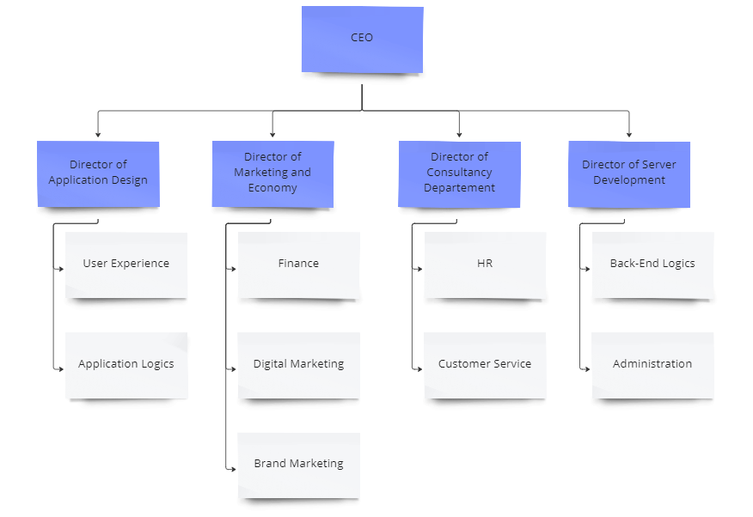

# Risk management

# Risk Profiles

## Risk consequences

### Server overload & connection problems

This is a very important problem, if there is a server overload the users won’t be able to use the application anymore for a certain amount of time. The same counts for connection problems.

### Ddos attack

The consequences of this risk depends on the size of the attack. If a large hacker/group Ddosses the system this can be fatal. But they are also small scripters which are not really a problem.

### Gps location error

People are still able to use certain features of the application. But they won’t get any/the wrong notifications when entering a dangerous area.

### Threat of hacking

The consequences of this attack depends on the size of the attack.

### Displaying the wrong information

This is not really that big of a deal, it’s just an annoying problem.

### Sensors stopped working

This is a problem we aren’t able to fix ourselves. But the consequences of this aren’t that big. We use data used over a month, not in real time.

## Risk likeliness

### Server overload

This is a risk that is unlikely to happen. If everything is programmed correctly this shouldn’t be able to happen.

### Ddos attack

Ddos attacks happen all the time. If everything is set up correctly this shouldn’t be a problem.

### Displaying the wrong information

After a lot of testing we should have fixed most of the display errors. So there is a low chance of a new one appearing.

### Threat of hacking

Hacking threats happen a lot. If everything gets updated correctly this shouldn’t appear this much.

### Connection Lost

Every server should be set up correctly, if this problem does occur it can be fixed relatively quickly. But it can still be a frequent problem.

### Sensor errors

This can happen a lot. We are not the owners of the sensors.

### Gps location errors

On mars gps isn’t that perfect at the time. This problem can happen a lot.

# Inventaris of risks

| **ID** | **Description** | **Impact** | **Probability** | **Risk Profile** | **Action** | **Various steps to undertake** |
| --- | --- | --- | --- | --- | --- | --- |
| R01 | Server overload | High | Low | Critical | Reduce | See 1 |
| R02 | Ddos of the system | High | Low | Major | Research | See 2 |
| R03 | Threat of hacking | Low | Medium | Major | Research | See 3 |
| R04 | Display wrong information | Low | Low | Minor | Eliminate | See 4 |
| R05 | Connection lost to the system | High | High | Major | Reduce | See 5 |
| R06 | Sensors stopped working | Low | High | Minor | Accept | See 6 |
| R07 | Gps location isn’t correct | High | High | Critical | Reduce | See 7 |

## Steps

1. Add more load balancing on the servers.
2. User a backup server.
3. Minimise data and encrypt data
4. Do more user tests.
5. Use a backup server.
6. More sensors, while the other is broken, we still have a backup sensor.
7. Get in touch with the GPS company.

## What if there is a security breach?

What's the impact of this and what data could be stolen? The application could be down for some time until the breach is fixed. If a hacker is able to retrieve user data, it will be hashed and salted. The data that the hacker could be able to read is the company data.

## What if there is a system failure?

What’s the impact and how long will the system be down? Of course if the system is down for a while this will be a major impact for the company. We are trying to help people by keeping them safe and giving them financial advice. If our service is down for a while we can’t keep people safe.

# Strategic partnerships

We want to work together with several other companies, one of those companies is Salus Security.

## Partner group

Group 11.

## Who

Salus Security

A community driven security company that works together to make an app that notifies people when they are in danger. This so that people are aware of incidents and can react to them appropriately. They also work on making graphical representations of all incidents registered. Their data is grouped on a monthly and yearly basis, this data we can use to display different criminal related dangers on our heatmaps.

## Company ethics

Without a police force, the world has become a dangerous place and thus people are in much needless danger. Besides that criminals run amok, while they should be isolated from society.

# Marketing and sales

## Objectives

### Objective

Our efforts will be focused on constantly updating and making the app better each month. We are focussing on helping businesses get the best locations and personal help for our premium business members. These will result in keeping our users and growing exponentially. By focussing on these objectives our revenue will be steady and our users will have a better user experience. After a while, we can find out from clients which parts of the application could be best automated, reducing the need of employees.

### Time Management

These objectives should be achieved in the first few years. When we are looking at a long term view, our services could be automated by all the data we have from the past years.

### Realisation

Our team will progress into this business by making use of good planning and keeping our progress on track. For further improvements we can team with other businesses in the area and build out our application even further with more data and visualisation.

## Ideal buyer

* Starting businesses looking for a profitable location on mars.
* Businesses looking for expansions
* Businesses looking for stats

## Sale strategy

### Normal User

For our normal users we will have to use ads for an income. We can provide an upgrade to premium membership. This allows us a steady monthly income from the memberships and still allows income of ads because of non paying users. For exact calculations you can go to the topic Financials.

### Businesses

For businesses we provide a unique business premium membership. Our income comes from the monthly payments of the subscriptions and the possibility to set up targeted ads. The amount of ads that are distributed are in control of the business itself. More ads equals more money. This income will not be as steady as our subscription income because of the ability to turn off ads for a month or two and start it up whenever you want to again.

# Marketing Strategy

## Customer

### Core

People using our application get informed about the problems on Mars through notifications and our heatmap. They don’t have to go through the trouble of looking for the information themselves. Our software also helps companies with picking a good business location and the right locations for targeted marketing.

### Actual product

The GeoAid application is not fixed in size. A user is able to change the resolution to their liking. Our design is easy to use, we don’t want people to waste time on bad designs. The heatmap, one of our main components, is easy to filter. We can filter on crime rate or temperature for example. Our live appointments are easy to manage, we don’t want businesses waiting on an employee.

### Augmented product

GeoAid will try to fix any bugs as fast as possible. We also think protecting our user information is an important aspect of our business. There is also a helpdesk that will solve any customer related issues. We will frequently update the app whenever this is needed.

### USP (unique selling proposition)

GeoAid is free and everyone is able to use it. Whether you are a company or a family, the application will help both. We keep a close eye on security and user data. We are unique in a way because a lot of features on the application are customizable. We are one of the biggest on the market when it comes to consulting companies about a new business location.

## Cost

### Free user

We won’t charge any money for a default user. Everyone is able to download the application for free. But this doesn’t mean we don’t want to make any money from these users. Because we still have the costs of our servers, application, developers, external companies and the help desk we need to make profit in a different way. We will be getting most of our profit from ads. These contain random ads but also user targeted ads.For the pricing of the free users we will be working with the **‘Cost-based pricing’** principle.

One of the benefits of working with this pricing strategy is that we will almost always make profit. But a disadvantage is that it may annoy the customers. If we make a lot of profit we will cut down on the amount of ads. If we are getting higher costs then the amount of ads will get higher. Every year we will look at the costs and decide whether we need more or less ads.

### Premium user

Premium users will be getting some extra features that’s why we will charge a fee for this. This will be 60 Mars coins every month. Because we don’t have that many extra costs because the application still runs on the same server, we won’t work with the Cost-based pricing principle. Because we care more about the satisfaction of our premium users we will be using the **‘Value-based pricing’** principle. We will work with a rating system if premium users aren’t satisfied with our service we will be lowering the price.

## Communication: extra means

How are we able to get new users for our application? We will be getting most of our new users from ads online. There will also be advertisements on events. We will also do some social media to attract new users. We also have an appealing site which will have a lot of traffic. We will be focusing on SEO too and try to limit the costs on SEA.

### Convenience

We want to make sure that new potential users are not confused by our design. We want our site to load in fast and make it easy to use. People should be able to download the application from the website in less than 10 seconds. Once the application is installed people are able to get help from the customer support. This will make them stay longer.

# Financials

## Costs

### Fixed costs

#### Staff costs

This includes but is not limited to the GeoAid developers, the help desk employees and consultants. Besides these people, we also have to pay our marketing and finances team.

A complete analysis of the staff costs would be as follows:

* 2 back-end developers worth 5000 Marscoins
* 2 application designers worth 4450 Marscoins
* 1 marketeer worth 2500 Marscoins
* 2 consultants worth 4000 Marscoins
* 2 help desk workers worth 3000 Marscoins
* The CEO worth 3000 Marscoins

Together these are worth 22 thousand Marscoins a month. After a whole year we will employ one more marketeer, making the total staff costs to 23.500 Marscoins a month.

After another year, our help desk will employ two more help desk staff and two more consultants, changing our staff expense to 30.500 Marscoins a month.

And one more year later, we will expand our business by employing another back-end developer and another application designer. Finishing with a monthly staff expense of 35.250 Marscoins.

#### Software Licences

We are using licensed software to make our application. This is a fixed cost that we need to keep in mind.

The following list contains all the licensed software we will be using:

* Office 355 costing us 600 Marscoins yearly
* Microsoft Azure for a record price of 4.000 Marscoins yearly
* IntelliJ Packet coming down to 2.000 Marscoins yearly

Together this brings us to a cost of 6.600 Marcoins every year. Which we divide as a monthly cost of 550 Marscoins.

#### Office instalment

We plan to work with a three year plan where every year we switch offices to accommodate the staff changes. Considering that on Mars we no longer make use of gas, since we can’t transport this here, living and work spaces exclusively make use of electricity, so we will not keep ourselves busy thinking about gas prices. The first year we will pay 1.500 Marscoins rent every month and 1000 Marscoins for Electricity, thus paying 2.500 Marscoins a month. The second year, after our upgrade we will find ourselves with 4.250 Marscoins a month worth of 2.500 Marscoins in rent and 1.750 Marscoins for electricity. Finishing in the third year with an astounding 5.000 Marscoins a month, this for the 3.000 Marscoins in rent and 2.000 Marscoins in electricity.

#### External data

To properly populate our application, we buy data from other sources, at this moment this results in a monthly cost of 550 Marscoins.

#### Monthly deprecation

The tools and machines we use will lose some of their worth at the end of every month. However, considering that we have so little of our own hardware in use, the resulting differences are almost negligible.

#### Advertisement

Advertisements are the veins that lead the customers to our business and thus incredibly important. For this cost, we want to play it safe, thus we use a fixed budget of 3.000 Marscoins a month. We will use this for online advertisements where every click on the ad that leads to a download of our application will cost us 3 Marscoins. Once we reach 10.000 we will up this budget to 5.000 Marscoins.

### Variable costs

#### Server

Our application will be running from a server. We have to pay the people who manage these servers. This cost might change because of the traffic rate. This cost should start around 300 Marscoins a month, however once traffic rate gets higher this number will increase. We might even have to buy our own server once the cost efficiency of hiring external servers is no longer positive. Once we reach 10.000 users the server cost will be around 500 Marscoins a month and when we get to 20.000 users a month this changes to 750 Marscoins.

#### Hardware

This stands for the cost of phones and computers for our personnel. As we don’t have to buy these every month, but have to buy a bunch in the starting months, we estimate this to be around 500 Marscoins, monthly.

## Revenue

Our main revenue is coming from ads and premium subscriptions.

Free users will get ads.

### Premium Users

Premium users will be paying 20 Marscoins a month. If they choose the year package they will get 2 free months. For them the app lets you view the crime rates in each neighbourhood. With this information we can provide them the best and safest spot to live.

### Premium businesses

Premium business accounts will cost 60 Marscoins a month. They will also get the option for a yearly package which gets them 2 free months. Businesses can see crimes like robberies in other businesses and crimes in different locations. This allows them to find their best location without having more chances of getting robbed or needing to move.

## Profit

After about 2 years we will be making profit. If we use the extra money from our investors, we will be able to cover our losses even faster, which means we would start making profit earlier.

## Break even

In the break even analysis we want to determine at what point we will make profit. And how long it will take until we are able to make profit. So first we have to know how much we need to sell in order to be profitable. Then we need to figure out when we will make profit. We also have to take into account the financial mix because we use external means from investors.

## Graph & table

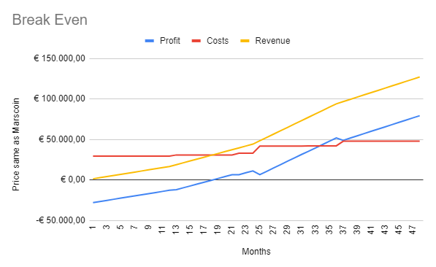



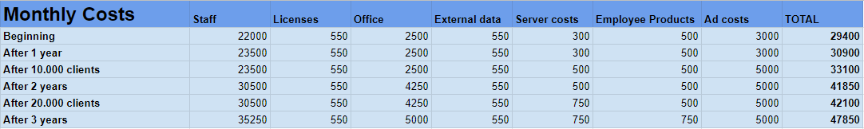

More information about our financial costs can be found [here](https://docs.google.com/spreadsheets/d/1j7P3sXgjzEFpmTfvqTn2EO1vrBAVQWqA2PC9lGo-A-U/edit?usp=sharing).

## Financial mix

Of course we need some investors to start implementing more features on the app. So we are mainly looking for private investors. But we are also going to start a crowdfunding campaign. This might look a bit weird, but we are helping all the people on Mars, so it is worth the money. Our company has a big opportunity to make a big profit margin so it should appeal to lots of investors. As a total we need about **250.000 - 300.000 mars coins for covering costs**. This amount is achievable by contacting investors and even crowdfunding. We can each invest about 10.000 which will be able to cover the remaining needs of our costs. Ofcourse we will also lend some money from the bank. The amount depends on how much money they want to lend us.

# Business Model Canvas

**Link:** https://miro.com/app/board/uXjVPUWK4oY=/?share_link_id=363148058166

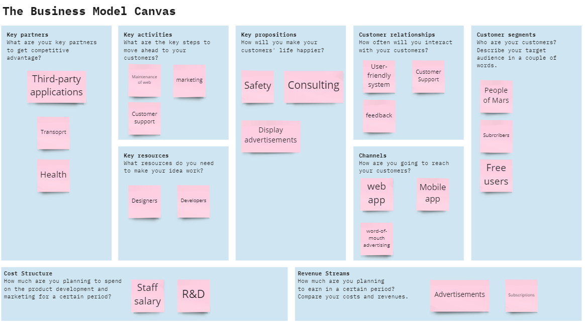

# Appendices